**Automated multi-well spheroid targeting and dynamic OCT-based assessment for 3D in vitro imaging**

Rameesa Rafi M H*a, Ibrahim Abd El-Sadeka,b, Rion Morishitaa, Shadil Basheera, Atsuko Furukawac, Shuichi Makitaa, Satoshi Matsusakac, and Yoshiaki Yasunoa

*aComputational Optics Group, University of Tsukuba, Japan. bDepartment of Physics, Faculty of Science, Damietta University, Egypt. cClinical Research and Regional Innovation, Institute of Medicine, University of Tsukuba, Japan*

**Keywords:** High-throughput imaging, dynamic optical coherence tomography, spheroid, automated sample targeting.

**Note: 3-page abstract can be found on the next page.**

**100-word abstract**

We present an automated sample targeting system (ASTS) for high-throughput, label-free imaging of 3D tumor spheroids using Jones matrix-based OCT. By integrating a motorized stage with synchronized OCT acquisition via TCP communication, the system enables fully automated imaging across a 96-well plate. It successfully targeted and imaged 15 tumor spheroids without any manual intervention. Functional imaging modalities such as LIV and OCDS were used to capture both structural and dynamic contrasts. Limitations including out-of-focus and out-of-field-of-view (FOV) spheroids, were observed, which highlights the need for future implementation of vertical axis control to improve spheroid localization and imaging accuracy.

**250-word abstract**

High-throughput, label-free imaging of 3D tumor spheroids is critical for accelerating biomedical research and drug discovery. However, conventional Jones matrix-based dynamic optical coherence tomography (OCT), though powerful for extracting both structural and functional information, remains limited by its manual operation, which makes the imaging process time-consuming and operator-dependent. To overcome this bottleneck, we propose an automated sample targeting system (ASTS) that integrates a motorized linear stage into the Jones matrix OCT platform. The system is controlled using a custom Python interface and enables fully automated, sequential imaging of multiple samples within a standard 96-well plate.

Using a two-dimensional linear translational stage and a brushless DC servo motor controller (BBD302), the system executes homing, precise jogging, and scanning steps via pre-calibrated well coordinates. The stage synchronizes with OCT acquisition through TCP communication, and assures reliable sample positioning without human intervention. We demonstrate the application of ASTS by targeting and imaging 15 MCF-7 breast cancer spheroids. Among these, 13 spheroids were successfully imaged; two showed imaging failures due to being out of focus or out of the field of view (FOV). These limitations are attributed to the 3D morphology of spheroids and their variable vertical positions in the well.

Functional OCT contrasts, such as logarithmic intensity variance (LIV) and OCT correlation decay speed (OCDS*l*), were acquired to provide dynamic activity maps. The system significantly improves imaging throughput and objectivity. The challenges encountered emphasize the need for future integration of vertical (Z-axis) control to enhance the reliability and precision of spheroid localization.

**Automated multi-well spheroid targeting and dynamic OCT-based assessment for 3D in vitro imaging**

Rameesa Rafi M H*a, Ibrahim Abd El-Sadeka,b, Rion Morishitaa, Shadil Basheera, Atsuko Furukawac, Shuichi Makitaa, Satoshi Matsusakac, and Yoshiaki Yasunoa

*aComputational Optics Group, University of Tsukuba, Japan. bDepartment of Physics, Faculty of Science, Damietta University, Egypt. cClinical Research and Regional Innovation, Institute of Medicine, University of Tsukuba, Japan*

# INTRODUCTION

Tumor spheroid is a three dimension (3D) culture of cancer cells that closely emulates the structure and micro environment of in *vivo* solid tumors **[Ref]**. Therefore, tumor spheroid has been widely used for the anti-cancer drug investigations **[Ref]**. Where the efficacy of anti-cancer drugs can be assessed by its impact on the spheroid’s morphology and cell viability.

High-throughput and label-free imaging is essential for efficient and reproducible analysis of the spheroids drug response. Dynamic Optical Coherence tomography (OCT) is a label-free functional extension of OCT that has been widely used for tumor spheroid imaging and its drug response analysis [**Ref**]. Despite the DOCT is a label-free modality, it’s ability for high throughput imaging is limited. This is because the manual and frequent sample targeting and repositioning requires a long time. According to our knowledge, imaging a single spheroid in 96-well plate requires approximately 5 minutes, including targeting. It means scanning the 96-wells requires 8 hours, which sacrifices the high throughput imaging ability and limits the temporal-resolution of time-course studies.

In this study, we propose a fully automated XY-translational stage controlled system, so called “automated sample targeting system(ASTS)” and integrated it with a swept source OCT device for automatic targeting and DOCT imaging of tumor spheroids in 96-well plate. The utility of the proposed system has been investigated for targeting and imaging 15 breast cancer (MCF-7) spheroids located in three different rows and five columns of a 96-well plate.

# METHOD

### Initialization and setup

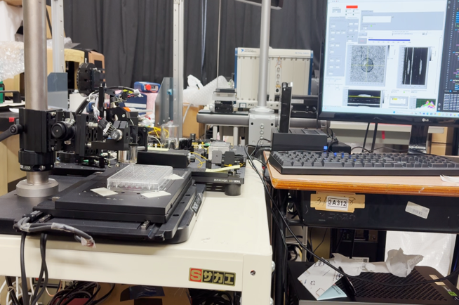

Fig.1 ASTS integrated with the DOCT microscope

Figure 1 shows the photograph of the ASTS system integrated with the DOCT microscope. The ASTS system consists of a motorized XY linear stage platform (MLS203-1, Thorlabs Inc., USA) driven by a brushless DC servo motor controller (BBD302, Thorlabs Inc., USA). A custom written Python program is used to control the stage movement, beginning with homing (moving the motorized stage to a predefined reference position), followed by jogging (small, incremental movements for precise positioning).

As the next step, the standard layout of a 96-well plate (8 rows×12 column, with a distance of 9 mm between the adjacent wells) is used for coordinate distribution. In this coordinate distribution, the centre coordinates of each well were defined as the coordinates where the stage is intended to move (see Fig. 2). A 9 mm increment (the　distance from the centre of one well to the adjacent well) is distributed to both the rows and columns of the well plate. Hence, the stage can move in a controlled manner throughout the scanning time, and can efficiently target each well.

### Synchronizing the stage control and automated OCT acquisition

The motorized stage, which is controlled via Python, and the OCT system, operated through LabVIEW, were integrated using a TCP/IP communication protocol of LabVIEW. This architecture ensures coordinated movement of the stage and timely image acquisition without manual intervention. In this setup, the Python script functions as the master by sending TCP signals to LabVIEW to trigger OCT image acquisition after positioning the stage at each well. LabVIEW, functioning as the acquisition client, waits for incoming commands and performs acquisition accordingly. Once the acquisition of one well is completed, the Python program monitors and confirms the OCT raw data saving, and then moves the stage to the next well for further acquisition. In this way, automated sequential imaging of the 96-well plate is achieved and fully eliminates the manual interventions and ensures precise timing between jogging and acquisition.

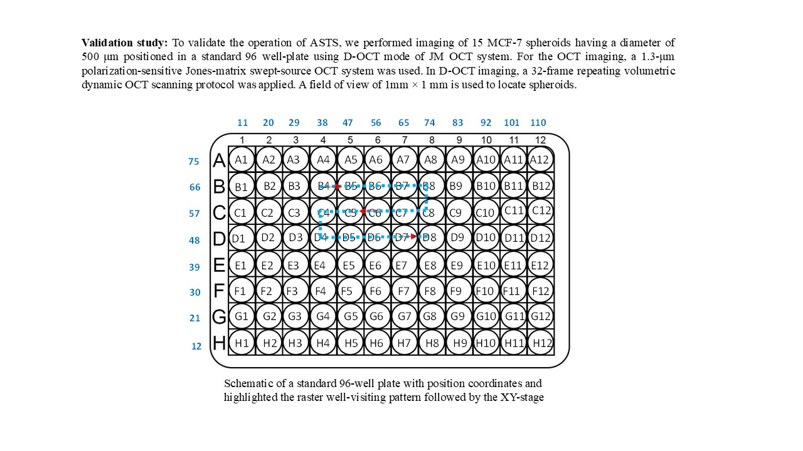

Fig 2: Schematic of a standard 96-well plate with position coordinates and highlighted the raster well-visiting pattern followed by the XY-stage

### Sample preparation and scanning protocol

The operation of ASTS is validated by imaging 15 MCF-7 spheroid samples having a size of approximately 500 μm. 1,000 human breast cancer cells (MCF-7 cell-line) were seeded in 15 wells (as highlighted in Fig. 2) of a U-shaped bottom ultra-low attachment 96-well plate to form one spheroid. After 6 days of cultivation, the 96-well plate was extracted from the cultivation environment, held on the XY translation stage, and automatically measured using the proposed automatic microscope. Notably, before starting the acquisition, the label of the wells contains the spheroids were predefined in the Python control program. The Python-controlled XY translation stage followed a raster well-visiting scanning [ blue dashed line in Fig. 2] starting from B4 ( contains spheroid 1) up to D8 (contains spheroid 15) by completing the acquisition across all the wells.

A 1.3-μm swept-source OCT device, operating at a speed of 50,000 A-lines/s, is used in this study. The objective used was LSM03 (Thorlabs), which has an effective focal length of 36 mm and provides an axial (in tissue) and lateral resolutions of ?? and 18.1 μm, respectively. For DOCT imaging, a lateral imaging field of 1 × 1 mm2 was divided into 4-blocks and each block consists of 32 B-scan locations [**Ref**]. Each block was raster scanned 32 times in 6.55 s. Hence, at each B-scan location, 32 repeated frames were captured with an inter-frame interval of 204.8 ms. An OCT volume comprising 128 locations was captured in 26.4 seconds for each sample.

**2.4. DOCT algorithms**

To assess the intracellular dynamics, we used two DOCT algorithms: logarithmic-intensity variance (LIV) and OCT correlation decay speed (OCDS*l*) **[Ref]**. The LIV is computed as the time variance of the logarithmic (dB-scaled) OCT intensity. And it was supposed to be sensitive to the occupancy of the dynamic scatterers within the tissue **[Ref; Rion]**. The OCDS*l* is defined as the slope of the autocorrelation decay curve of the sequentially captured OCT frames at each B-scan location at a delay range of [??, ??]. OCDS*l* was supposed to be sensitive to a certain velocity range of the intracellular scatterers **[Ref; Rion].**

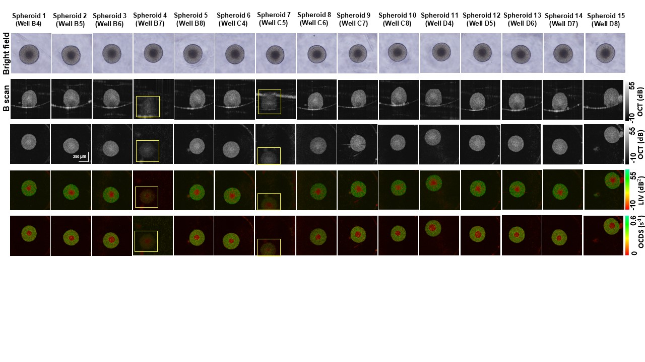

Fig 3: Automatically captured OCT and DOCT images of MCF-7 spheroid. The panel includes bright field, OCT B-scan and enface, and the corresponding LIV and OCDS *en face* images of 15 MCF-7 spheroids acquired automatically. The spheroids that were out of focus or out of the field of view (FOV) are highlighted by the yellow squares.

# RESULTS

Figure 3 shows the Bright filed, OCT, and DOCT images of the 15 measured spheroids. Out of the 15 spheroids targeted, 13 were successfully imaged using the automated system. And they exhibited the well-known DOCT patterns of the spheroid. Namely, the spheroid centre exhibited reduced LIV and OCDS*l* signals (red) [Fig.3 (4th and 5th rows, respectively)], which collocated with the dark appearance in the bright field images [Fig.3 (1st row)]. It may indicate the well-known necrotic core of spheroid, likely caused by hypoxia and limited nutrient availability **[Ref]**.

The remaining two spheroids [Highlighted by the yellow boxes in Fig.2] didn’t show a clear contrast. It might be because they were out of focus and/or out of the field of view. The out of focus issue can be attributed to the variations in the culture medium volume among the wells. On the other hand, the out of the field of view issue might be attributed to the slight shift in the spheroid location. Namely, the spheroid was not exactly located at the centre of the well. To overcome these limitation, further extensions of the proposed ASTS system is required as discussed in the Discussion section.

# Discussion

* 1. **Further extensions of the current system**

As discussed in the result section, out of the 15 spheroids imaged, two spheroids were out of focus and/or out of field of view issues. Those spheroids were likely in the different depth and is slightly relocated from the centre position of the well. The intra-well variations of the culture medium amount leads to a slight change of the focus positon among the wells. To address this limitation, a precise vertical control of the OCT probe by integrating an automated Z-axis translation stage into the current XY ASTS system is going to be implemented in the near future. On the other hand, for more accurate lateral positioning of the spheroid, real time NN-based segmentation of the spheroid is going to be performed. Based on this segmentation, the spheroid central coordinates are going to be determined and fed to the XY stage control to positon the stage not at the centre of the well (current implementation), but at the centre of the spheroid. Additionally, combining the current microscope with the NN-based high speed DOCT imaging (requires only 4 repeated frames at each location) developed by our group **[Ref. Yusong LIV]** will significantly increase the speed of the proposed system and enables scanning 96-wlls in approximately 15 minutes.

### Importance of the proposed system.

The automated DOCT microscope described, along with the future developments outlined in Section 4.1, is intended to serve as a fully automated platform for high-throughput imaging of in vitro cultures. This system holds promise as a valuable tool for anti-cancer drug screening. Its automatic targeting capability enables researchers to perform time-course imaging of tumor spheroids with high temporal resolution (i.e., shorter intervals between successive measurements), facilitating fine analysis of spheroid-drug interactions over time.

# CONCLUSION

We demonstrated an automated sample targeting system (ASTS) and integrated it with dynamic OCT microscope for high-throughput, label-free imaging of tumor spheroids. The integration of an XY motorized stage with synchronized OCT acquisition via TCP communication enabled fully automated imaging of spheroids within a 96-well plate. A set of 15 spheroids in a 96-well plate were successfully imaged. Among them only two spheroids appeared to be out of focus and/or FOV. These limitation are going to be addressed by integrating an additional depth-axis (Z-axis) stage for tuning the focus position and establishing an image-based segmentation method, which will enable fine 3D positioning of the sample within the imaging field. The proposed system might be a useful tool for high throughput spheroid based anti-cancer drug screening.

# REFERENCES

[1] S.Pi et.al., *Opt. Lett.* **49**, 4481 (2024) [2] V. Lob *et al*., Med. Biol. Eng. Comput. **45**, 1023 (2007) [3] T. Geisler *et al*., IEEE Trans. Autom. Sci. Eng. **3**, 169 (2006). [4] I. A. El-Sadek et.al., Biomed. Opt. Express **12**, 6844–6862 (2021).